**Box Top Submissions**

**Install the Box Top Application on Phone**



**Be sure to add your school and email when you register in order to earn for your school. This is located under your profile.**

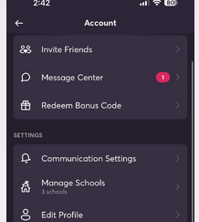

**Learn about ways to earn by checking Bonus Offers and Applicable Products**

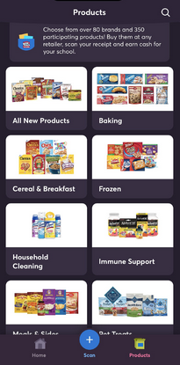

**Box Tops does require that you purchase certain brands to earn credit.**

**Once you have shopped and have a receipt to upload to the app you have a couple options on how to submit them:**

1. You can use your email and send box tops directly. Forwarding receipt emails using the instructions below.

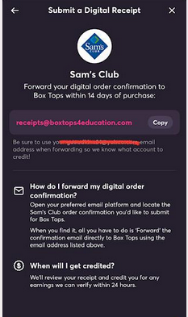

1. You can also submit by sending in photos from your digital receipts on your Walmart app.
   1. 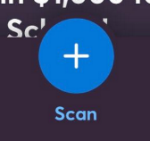Take pictures of your receipts from your account on the Walmart app. (be sure to include the applicable products and total in the photos)
   2. Click on the Scan button (bottom center of app)
   3. Choose digital receipt
   4. Choose Walmart or another store
   5. Select UPLOAD to select the photos from your phone (choose from camera roll)
   6. Click Submit

